2016 South King County Democrats Dinner
Silent Auction
“Putting the WE in We the People”
Saturday, June 4, 2014, 5:00 pm
IAM Hall
9125 15th Pl South -- Seattle, WA 98108

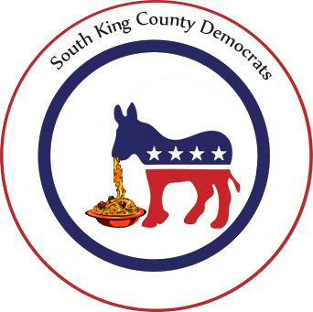
AUCTION ITEM PROCUREMENT FORM

Deadline for donations is MAY 31 (please ensure items are at the event by 4 pm on June 4)
Please transmit completed form ASAP to Tyler Page: pageranch47@gmail.com

Items donated to South King County Democrats Dinner
Federal Tax ID: 33-1121864 11th LD: ________

Auction volunteer name and phone: ___Emily Willoughby 206-241-5885_____________

DONOR INFORMATION
Donor/Company Name:
Donor/Company Address:
Donor Contact Name: | Phone:
Donor Signature: | Date:

ITEM INFORMATION
Name of item:
Estimated (fair market) value: $ | Exp Date (if app):
Item description to be used for display (write here or attach): Please be specific, but concise! Please include quantity, size, color, restrictions/limitations, and other pertinent information.

FOR OFFICE USE: please make a copy of this completed form for the donor
Item Auction Number:
This item is Tangible/Intangible (circle one)  If tangible: will item be displayed at the auction?  If intangible, is there an image to use for display at auction?  (If intangible, gift certificate must be provided by donor) | Y / N  Y / N

